THE IMPORTANCE OF INDIVIDUAL CBT CASE FORMULATION IN THE RECOGNITION AND TREATMENT OF BURNOUT

M.Swift BSc (Hons), MSc, Cert. CBT, MBPsS.

A Dovey, MSc, RMN, DPSN

Introduction
Burnout is identified as an occupational health concern that involves the combination of several negative physiological and psychological symptoms associated with work-related stress (WHO, 2019). Although burnout is not recognized as a distinct disorder in the current version of the diagnostic and statistical manual of mental disorders (DSM-5), the International Statistical Classification of Diseases and Related Health Problems (ICD) has previously classified burnout as a form of non-medical life management difficulty.

Occupational Burnout
In early 2019, the WHO updated their classification of burnout, particularly relating the phenomenon to specifically occupational scenarios in which problems with employment or unemployment may arise (WHO, 2019). Specifically, burnout as stated by the WHO refers to ‘factors influencing health status or contact with health services’; a specific classification related to elements external of recognized diseases or health conditions (WHO).
By definition, burnout arises due to the lack of ability to cope with crises and onset of negative physiological and psychological symptoms (Khamisa, Peltzer & Oldenburg, 2013). Although research identifies several symptoms associated with burnout, the most frequently reported within the literature include: - exhaustion and inability to perform tasks, losing motivation including work, an inability to focus or concentrate on tasks, feeling empty or lacking in emotion, experiencing conflict in relationships with co-workers and withdrawing emotionally from friends and family (Heinemann & Heinemann, 2017).
A prominent study examining the outcomes of occupational burnout, was conducted by Salvagioni et al. (2017). The authors conducted a systematic review of 993 articles and utilized 36 that met the relevant criteria for burnout. The study noted that burnout was widely highly common within work-place settings and affected a significant population of employees. Burnout was identified as a significant predictor firstly of negative physical outcomes including coronary heart disease, respiratory issues, type 2 diabetes and mortality below the ages of 45 years. In addition to physical outcomes, the study highlighted severe psychological effects including depressive symptoms, hospitalization for severe mental disorders and increased use of anti-depressants. A strong finding within this review was the professional outcomes associated with burnout, these included job dissatisfaction, high job demands and frequent absenteeism associated with high costs to organizations. The study concluded that the majority of studies identified several negative consequences of job burnout and highlighted the necessity for acceptance of burnout as a classification and requirement to improve working environments for employees.
In addition to negative health outcomes, it is posited that currently organizations are facing an employee burnout pandemic, recent studies in America have suggested that an estimated £150 billion is spent on health-care expenditures due to burnout each year (Garton, 2017). This figure appears well justified considering that further explorations into burnout identify that 25% of employees identify feeling burned out at work very often and 45% reported feeling burned out sometimes; this would suggest that roughly two-thirds of employee’s experience burnout in occupational settings (Wigert & Agrawal, 2018).

Although there have been many interventions to try and reduce the role of occupational burnout within the workplace, there is an increasing pool of evidence suggesting that cognitive behavioural therapy interventions (CBT) can serve to decrease stress and psychopathology, in addition to reducing sick leave in employees (Odeen et al., 2012).

CBT Formulation
Cognitive behavioural therapy is a well-documented therapeutic technique used widely in the treatment of anxiety, depression and other psychopathological disorders. CBT relies heavily on formulating the clients’ difficulties and implementing therapeutic techniques to reduce client concerns. This process often starts with a case formulation. A case formulation is defined as a hypothesis about the nature of the psychological difficulty (or difficulties) underlying the problems on the patient’s list of difficulties (Huisman & Kangas, 2018). In Cognitive Behavioural Therapy formulation primarily focuses on the underlying negative automatic thoughts of the client that become trapped into vicious cycles with dysfunctional emotions, behaviours and somatic symptoms (Huisman & Kangas).

Formulations are also typically expanded to explore ongoing dysfunctional cognitions in the form of Assumptions and intrinsic Core Beliefs. Case formulations are utilized by clinicians to guide and configure the course of treatment sessions by prioritizing symptoms, exploring the choice and timing of interventions, and recognizing the possibility of future problems and relapse within the therapy (Mumma & Fluck, 2016). Cognitive case formulations are contrasted to medical diagnoses as they are open to disconfirmation; permitting the constant review of symptoms, interventions and working hypotheses for psychological issues (Kuyken, Padesky & Dudley, 2008). Case formulations are grounded in empirical research, parsimonious, and readily understandable by clients, this permits for a strong therapeutic relationship in that the client can work collaboratively in identifying and working towards cognitive and behavioural changes (Macneil et al., 2012).

Jacqueline & Lisa (2015), suggest that the main strength of the cognitive case formulation is its openness to modification that is not present in other modalities such as psychoanalytic approaches. Within the formulation, the therapist should never display their certainty of their hypotheses or underlying mechanisms of the behaviours and cognitive interactions, it is this continuous process of revision, testing, revising and rejecting concepts that promotes the scientific evidence base of the cognitive model and such formulations (Jacqueline & Lisa). Leading on from this, the largest strength of cognitive case formulations is their grounding in empirical research evidence. The ability to use formulations as a hypothesis testing structure has boded significantly well within studies of CBT with psychopathology (Hoffman et al., 2012; David, Cristea & Hoffman, 2018). Subsequently it is suggested that it is this system of psychotherapy with a unified theory of behavior, thoughts, emotions and psychopathology supported by substantial empirical evidence that provides such strengths to the formulation model. Within clinical practice, cognitive formulations are designed to be understandable, and easy to use collaboratively with clients. Although this serves to enhance the collaborative nature of the therapy, this feature has been criticized for its possible reductionism of complex psychological dynamics (Holmes, 2002).

CBT & Burnout Maintaining Processes

The maintaining processes of occupational burnout are typically generated through formulations with the clinician during the first sessions of CBT, and are gradually and continually adapted in line with new information from the client. The CBT model around beliefs and burnout are generated via previous experiences of burnout and the views held by the individual of their intrinsic capacity and societal view (Ahola, Toppinen-Tanner & Seppanen, 2017). It is the individual’s beliefs that dictate their monitoring of emotional fatigue and exposure to daily stressors within the workplace.

Moss-Morris et al. (2005) suggest that one of the maintaining processes of burnout is related to hypervigilance for the sensations of emotional fatigue which increases the selective attention paid to it. In turn this increases the level of fatigue by bringing this into the individual’s conscious awareness. Most frequently Moss-Morris suggests that the attention is directed to symptoms more-so than adaptive coping mechanisms which in turn increases negative beliefs. Once the individual notes the sensation of emotional fatigue these will typically trigger negative automatic thoughts (NAT’s) such as ‘I am not achieving well enough’, ‘I am a failure’ or ‘I can’t cope’. Subsequently these thoughts lead to increased attempts to avoid stressors and lead to beliefs and safety behaviours which make the burnout both increasingly truthful for the client and paradoxically- more stressful. Fundamentally, both reduced self-efficacy and the failure to disconfirm fears act to strengthen negative thoughts and is therefore perceived as an inability to meet demands of their occupational role (Button et al., 2018).

CBT Case Formulations
The role of individual formulation for clients provides a unique conceptualization to support them in understanding what their difficulties are, where they originated, and what keeps them going (Johnstone, 2017). Formulations can typically consist of ‘maintenance’ and ‘developmental’ components. Maintenance formulations typically consist of the immediate factors that ‘maintain’ an issue whereas developmental formulations rely on previous schemas and learnt behaviours that have led to and maintain the problem (Fenn & Byrne, 2013). The ‘five P’s’ model is a formulation that serves to integrate aspects of both maintenance and developmental formulations and has therefore become one of the cornerstone models of formulations (Macneil et al., 2012).

The ‘Five P’CBT case formulations have 5 components:
- Predisposing factors which made the individual vulnerable to the problem
- Precipitating factors which triggered the problem
- Presenting problem(s)
- Perpetuating factors such as mechanisms which keep a problem going or unintended consequences of an attempt to cope with the problem
- Protective factors that provide emotional resilience or reduce stressors

The formulation model will be used below to conceptualize a case study. The individual within the case has experienced stress which has resulted in symptoms of occupational burnout. The case study has been constructed to reflect real world examples of individuals within the workplace who have experienced burnout and sought support from CBT therapists. [These case studies are fictitious and do not reflect any sole individual.]

Case Study
Case Introduction
Jane is a 29-year-old female who works as an interior designer for a large car manufacturer in the Midlands. Jane has self-referred to occupational health as her partner has recently a significant change in her overall mood. On informal assessment by occupational health, they reported that Jane feels an increasing amount of pressure that she believes is stemming from her increasing work demands and prolonged working days both in and outside of the office. Occupational health contacted Jane’s supervisor with her permission. Her supervisor noted that Jane had often looked tired at work and was becoming increasingly concerned as she appeared teary throughout the day. In addition, it was shared that although Jane’s performance was not ‘bad’, she had become less creative with her designs and slightly behind on her scheduled activities.

Case Formulation
Jane attended my outpatient clinic on xx/xx/xxxx. Jane attended this appointment on her own. Jane was referred by her occupational health team at work to seek CBT for stress, anxiety and general low mood.

Leading up to her self-referral, Jane told me that she had isolated herself from her colleagues and her friends. She recently found out that one of her close friends had received a promotion into a role that she would have liked herself. This led her to feel like she has not done well enough in her own work. Jane told me that from a young age she felt like she had to be the best at everything that she did and would not settle for ‘underachieving’. To overcome this, Jane had been working 16-hour days, often taking her interior projects home and working on them over the weekends and evenings. This had been going on for almost a month. Jane told me that last week she felt like she had reached a breaking point and she lost all interest in work and became very emotional, often crying during her breaks.

Jane presented with feelings of anxiety, low mood, tearfulness and burnout. Jane has been exponentially increasing her working hours to overcompensate for the fact that she feels her professional life is not progressing as it should. Jane has developed some safety behaviours to hide her emotions and appears to have reached a point of burnout where she is now exhausted and lacking interest in work.

Jane informed me that to avoid feeling anxious about her upcoming deadlines, she had been significantly increasing her working hours in order to try and attain a promotion. Jane has only been sleeping 3-4 hours a night due to working through large portions of the night. Jane has continued to do this as she feels that she has been under achieving and has therefore been avoiding any conversation regarding her current work or the projects that she has been working on. In addition, Jane has agreed to take further projects on even though she has been struggling with her existing tasks. Jane has been crying multiple times throughout the day and she often hides in the bathrooms at work and at home to hide the fact that she is struggling. She has now started carrying eye drops everywhere and displaying these to anyone who is asking if she is upset.

Jane feels like in general she is quite a resilient individual and within her previous role she felt adequate of dealing with high stress environments. In addition, Jane feels her partner is very supportive of her mental health and they are able to adequately communicate. Jane does not smoke or use recreational drugs and only drinks alcohol occasionally at family events.

Burnout Developmental Model
There are several processes that determine the onset of occupational burnout. Although studies have examined how burnout can occur and the subsequent effect it can have on the individual, there appears to be a lack of specific CBT-based formulation models for this phenomenon. Below is a conceptual model that takes into account developmental and maintaining factors that are suited to a CBT approach. This model as outlined below is based on four components- the developmental concept of Clarke’s (1986) ‘model of panic’, the maintaining processes of cognitive therapy often referred to as a ‘hot cross bun’ and the outcome of positive adaptation or occupational burnout.

Clarke (1986) and further CBT evidence suggests that our behaviours and outcomes begin with existing beliefs or schemas that through a certain trigger lead us to evaluate a threat on a continuum between severely distressful and non-distressful (Fenn & Byrne, 2013). The model below suggests that beliefs about an individual’s job act as the basis for how they will react to triggers and furthermore perceive threats. For example, an individual who believes work is not important in their life, is less likely to experience possible triggers leading to high threat appraisals.
Figure 1. Occupational Model of Burnout
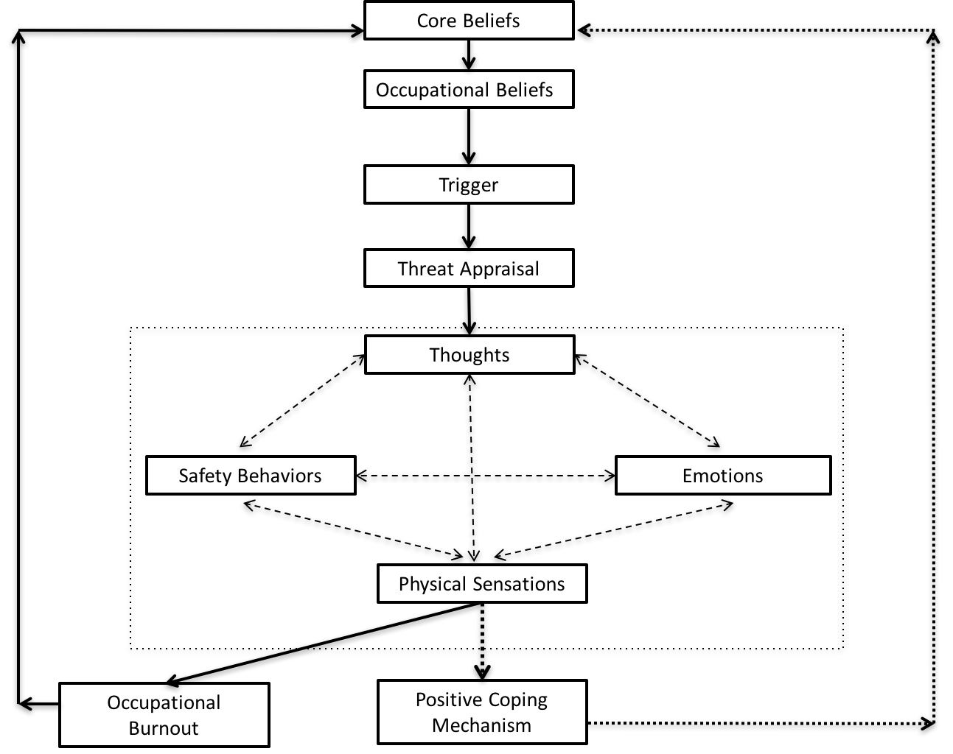

The second component of this model is the maintenance model (hot cross bun) and interaction of the cognitive behavioural components- thoughts, emotions, physical sensations and (safety) behaviours. The clients perceived threat appraisal is hypothesized to lead to the activation of negative automatic thoughts (NAT’s). From this contained aspect of the model, each of the thoughts, emotions, physical

sensations and safety behaviours will typically display a reciprocal relationship; such that increased negative physical sensations will lead to further safety behaviours and vice versa. As the current working model within CBT is that pre-existing schemas lead to how we interact and express each of the maintenance model aspects, it is suggested that the developmental aspect is a separate yet progressive introduction to the maintenance model which then results in two outcomes.

It is proposed that the culmination of the occupational beliefs and maintenance model will result in two outcomes. These outcomes are expressed as the third and fourth components of the burnout model; subsequently occurring in the absence of distress or development of sufficient means to deal with stressors defined as ‘positive coping mechanism’. Alternatively, the individual may struggle to adapt to their stressors and subsequently remain in a state of chronic negative arousal; leading to occupational burnout. When utilizing this model, it is imperative to utilize the maintenance model within the center as the outcome of the initial developmental phase and precipitating factor to burnout and positive coping mechanism. By following this systematic model, it provides a comprehensive yet succinct process for identifying and defining occupational burnout.

Case Burnout Model
Using the above model, we will now incorporate the case of Jane to understand how the formulation of specific occupational burnout can be conceptualized. Within figure 2, a formulation for case specific burnout has been utilized to identify the precipitating, trigger, presenting and perpetuating factors of Janes negative emotional wellbeing.
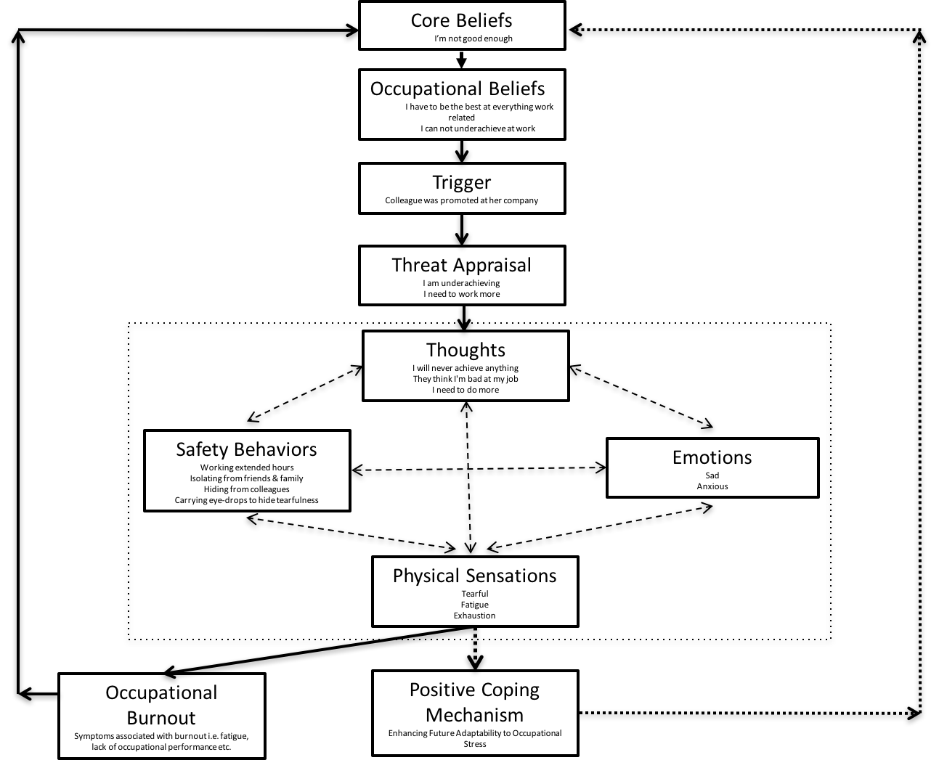
Figure 2. Individual Formulation

Core Beliefs
Janes core beliefs are posited to be the fundamental schema upon which her ontological beliefs are based. Therefore, her core beliefs most likely developed within early exposure, and serve as a basis for conceptualizing both her internal and external experiences. Within this formulation, Jane was asked to think of a recent event where she felt particularly stressed. Using Socratic questioning techniques, the clinician explored this event in which Jane felt overwhelmed with work and experienced being ‘unable to cope’. Using a downward spiral to explore the ‘worst case’ scenario for this statement she shared that since childhood she had never felt good enough. This therefore serves as the basis of core beliefs that subsequently impact occupational beliefs and the proceeding burnout model.

Occupational Beliefs
Jane mentions that schemas or foundational beliefs are related to high expectations of herself. She notes that she has had traits of overachieving and desire to ‘be the best’ since childhood and it therefore appears that her occupational beliefs encompass the necessity to be the best at her job; meaning that any perception of underachieving is not an acceptable position for herself to be in.

Trigger
It appears the triggering mechanism within Jane’s formulation is the promotion of her colleague. Jane refers to the promotion as the precipitating factor the chain of events that ensued; therefore, leading the practitioner to denote this as the most likely trigger.

Threat Appraisal
Based upon Janes occupation beliefs, it appears that she is viewing the notion of underachieving as a threat which is causing her significant distress. This has become troublesome for Jane as she has also interpreted this threat as a necessity to work further hours within her role which has served to perpetuate her issues. This high threat appraisal of occupational demands is subsequently what leads into the negative cycle of the maintaining factors below.

Thoughts
The negative threat appraisal above has led Jane to express typical negative automatic thoughts (NAT’s) in relation to her occupational role and existing occupational beliefs. Jane’s negative beliefs use her core beliefs and internalize them to her work; most notable Jane mentions that she will ‘never achieve anything’ and further thinks that her colleagues believe her to be incompetent within her role. The expression of negative thoughts within Janes case therefore appears to be the leading negative cognition that is maintaining her process of distress.

Emotions
Jane provided the link between her negative automatic thinking and emotions. The emotions that Jane mentioned included feeling sad and anxious for significant periods of time both within and outside of work. The clinician asked Jane if she thought if it was more or less likely that having thoughts that she was ‘never going to achieve anything’ would lead her to feel more or less likely to note sad or anxious feelings; to which Jane suggested more.

Physical Sensations
Jane noted a bilateral relationship with her physical sensations such that the sadder she felt the more physical sensations she experienced and vice versa. The physical sensations suggested by Jane included fatigue, exhaustion and tearfulness which appear related to her emotions and perpetuated by her safety behaviours.

Safety Behaviours
Jane identified a further reciprocal relationship between her physical sensations of exhaustion and tearfulness with safety behaviours including working extended hours, hiding from colleagues and carrying eye drops. This appears plausible as naturally the more hours that Jane works, the more likely she would feel tired. Furthermore, the experiencing of feeling tearful would be more likely to perpetuate carrying eye drops to reduce short-term distress. Finally, safety behaviours were linked back to negative thoughts, such that avoiding colleagues made Jane feel more likely to be interpret her colleagues as thinking she was not sufficient within her role in addition to feeling that she was underachieving.

Occupational Burnout
Occupational burnout is one of the two routes of outcomes within the model. As well defined in the literature, individuals who struggle to meet the physical and emotional demands of their role typically express symptomatology synonymous with burnout. Within Jane’s case study, her inability to moderate her cognitions, behaviours and physical symptoms has led to the classification of burnout. The symptoms associated with this burnout route can clearly be seen within Janes case including reduced work performance, exhaustion and fatigue, cynicism and notable psychological distress (WHO, 2019).

Positive Coping Mechanism
Although this component has not been activated with Janes formulation, this process would become relevant if a more suitable coping style was adapted. Subsequently if Jane for example, viewed her colleague’s promotion as threatening, however instead implemented the cognitions not based in her own selective bias, it is much more likely that she would not relate this with negative cognitive and behavioural strategies. Therefore this pathway relates back to reinforcing positive core beliefs if a notably effective coping strategy has been implemented to competently reduce distress.

Formulation Conceptualization
From this formulation model, we can subsequently see the precipitating, presenting and maintaining factors within Jane’s development of occupational burnout symptoms. The utilization of such a model provides a framework for establishing the formulation of burnout and the possible subsequent interventions that are necessary to reduce the negative circularity of the client’s thoughts, emotions, physical sensation and safety behaviours. It would be suggested that this model be utilized to explore specific formulations in relation to occupational burnout as a means to assess the therapeutic hypotheses and support clients in the understanding of such burnout phenomena.

Further Considerations
Formulation Structure
Within the case formulations above the 5 P’s model has been utilized to work through predisposing, precipitating, presenting, perpetuating and protective factors. Although it can be seen that the formulation structures remain widely similar, there are slight modifications that are used to best facilitate the client’s clarification of their presenting issues.

Eells (2009) research suggests that although formulation structures are somewhat standardized in delivery, they allow for exploration of the clients’ issues in a collaborative and non-diagnostic paradigm. It can be seen within Jane’s formulation that there appeared to be no predisposing factors in relation to family history or prior episodes. Within CBT and

its associated formulations, there exists a large emphasis on the client leading with the issues that they wish to focus on and work upon maintaining rather than initiating factors; subsequently this shows that formulation structures although somewhat systematized do not always necessitate every component. In relation to the identification of burnout, this is important, as we need to recognize that jumping to immediate conclusions or pushing the client to divulge information that they may not deem as relevant to their current experiences can seek to damage the therapeutic process and relationship. Therefore, individual formulations allow a holistic and structured; yet collaborative and empathetic guide for issues to be addressed within the therapy room.

Identifying Burnout
Identifying the possibility of occupational burnout is one of the strengths of using a cognitive based formulation for CBT purposes. As is seen within the model and case study, the Jane express aspects of burnout syndrome including exhaustion, lack of performance, reduced engagement with work and some negativisms. Unlike purely diagnostic assessments, the formulation serves to identify how overcompensation and avoidance have led to burnout. Jane have been working excessive hours and placing significant pressures on herself to be a high achiever within her role. Therefore, we can identify the progression from precipitating factors, through to their presenting issues of stress and anxiety, then further to aspects of avoidance that are perpetuating such issues. (Redhead, Johnstone & Nightingale, 2015) suggests that it is this ability to identify the progression and initiation of presenting issues that most informs the clinicians ability to implement interventions and test hypotheses. Although it can be argued that burnout could be established solely from a diagnostic criterion as identified by symptomatology alone, the context provided within detailed formulations provides more succinct mechanisms and can be utilized across a range of occupational scenarios within large populations of clients.

Safety Behaviours
Within the case study, it is apparent that Jane is displaying safety behaviours that are both precipitating and perpetuating her current difficulties. Safety behaviours are coping mechanisms that serve to reduce anxiety and fear when a perceived threat is identified (Aderka et al., 2013). Such examples can include people with social anxiety who think of excuses to escape what they perceive to be as an uncomfortable environment. Although these behaviours reduce anxiety in the short term, they can become maladaptive over long term periods by prolonging the fear of non-threatening scenarios (Meyer et al., 2019). These responses typically prevent us from changing our cognitions as each ‘safe’ experience is associated with the success of the behaviours; therefore, reinforcing the perceived benefit of such behaviours.

Within the case above we can see the clearest example of safety behaviours where Jane has started carrying eye drops to prevent the anxiety of people knowing that she is upset. By incorporating these behaviours, each individual is reducing their immediate anxiety, but reinforcing the notion that they can either not be upset or manage to communicate with their colleagues. Identifying these safety behaviours is a crucial part of developmental and maintenance formulations and is clearly identified within perpetuating factors. This therefore displays how individual formulation can serve to determine the client’s symptoms of burnout and lead to the direct intervention of such behaviours to reduce long-term anxiety. Notably, it is more difficult to identify such symptoms in other modalities of therapy such as psychodynamic methods, which serves to strengthen the concept and implementation of idiographic CBT case formulations.

Overcompensation & Avoidance
Within the case above we see typical traits of overcompensation and avoidant techniques that serve to increase the likelihood of the individuals ‘burning out’. Current research suggests that individuals who overcompensate typically try to obtain strict order, tight self-control and devote increasing time towards finding the best way to accomplish tasks (Mairet, Boag & Warburton, 2014). Within the case study, we can see that Jane wants to progress within her occupational roles and has set beliefs about ‘needing to highly achieve’ and ‘not being good enough’. Jane therefore appears to overcompensate via recognition/status seeking traits that are most frequently associated with trying to impress, achieve highly or maintain status (Hofmann & Hay, 2018). There is a strong emphasis on friends, family or managers to know the extent of their stressors and this would therefore show how overcompensation and avoidance have interacted to produce the phenomenon of occupational burnout.

Jane is avoiding situations and certain individuals that she perceives will cause her distress. It appears that this avoidance is helping her to prevent stress in the short term, however maintaining them longitudinally. This subsequently shows how the individual CBT formulation is able to identify behaviours and cognitions that have led to safety behaviours, underlying beliefs that are then brought into the therapy room.

Therapeutic Interventions
CBT based formulations as utilized above permit the clinician to develop a comprehensive understanding of the client’s cognitions both prior and during the assessment process. A crucial aspect of CBT based formulations as above is to develop hypotheses and subsequently introduce therapeutic techniques to support the client. Although the above case serves to show the development of an individual formulation, similar examples with real clients are particularly common. The primary focus of CBT interventions is to moderate automatic negative beliefs and increase cognitive doubt about such unpleasant or distressing cognitions (Gaudiano, 2008). Therefore, although the clients present with different contextual formats, the therapeutic intervention will serve to moderate the individuals’ cognitions and provide them with a more rational belief.

In regards to the case above the formulation has shown evidence of overcompensation and avoidance in addition to stress, anxiety and isolation. Currently the evidence suggests that CBT-based stress management training combined with modifying beliefs about needing to ‘be the best’ results in a decrease in exhaustion and cynicism; subsequently reducing the amount of sick leave hours (de Vente et al., 2008). Furthermore, targeting safety behaviours such as avoiding managers or not engaging with colleagues through cognitive restructuring shows to also decrease exhaustion and depersonalization (Blonk, Brenninkmeijer, Lagerveld, & Houtman, 2006).

An emergent feature of the case above is the fact that Jane is significantly pushing herself to increase her working hours. Luken and Sammons (2016) have identified that utilizing mindfulness based practices including breathing activities and self-awareness tasks can serve to reduce the necessary working hours, or alternatively to reduce the stress associated with it. This would therefore also be a possible intervention to reduce the effects of burnout and decrease the likelihood of relapse in the future.

Conclusion
Case formulations are a central and crucial component of working with the client in a CBT based modality. Individual formulations provide a framework that is both grounded in research evidence and flexible to the negotiation of behavioural and cognitive hypotheses. In regards to burnout and particularly occupational burnout, case formulations provide a comprehensive view of the individual’s bio-psychosocial interactions and experiences. The cognitive case formulation allows the client to express their concerns without the immediate requirement for formal diagnoses and therefore allow for understanding the phenomena; tailoring specific burnout treatment protocols accordingly. It has been through the ongoing psychological literature that individuals present with idiographic experiences. The ability to utilize an individual formulation to tailor sufficient treatment plans and comprehensively understand the client should be the central component of CBT practices.

Occupational burnout is an increasingly alarming phenomenon for individuals and businesses, this case study approach shows the strong benefits of being able to identify patterns of behavior, establish prior history and support individuals who may overcompensate or avoid. It is the ability to moderate negative cognitions and beliefs combined with behavioural strategies to reduce stressors that will subsequently support individuals in continuing with their occupational demands.

References
Aderka, I., McLean, C., Huppert, J., Davidson, J., & Foa, E. (2013). Fear, avoidance and physiological symptoms during cognitive-behavioral therapy for social anxiety disorder. Behaviour Research And Therapy, 51(7), 352-358. doi: 10.1016/j.brat.2013.03.007
Ahola, K., Toppinen-Tanner, S., & Seppänen, J. (2017). Interventions to alleviate burnout symptoms and to support return to work among employees with burnout: Systematic review and meta-analysis. Burnout Research, 4, 1-11. doi: 10.1016/j.burn.2017.02.001
Blonk, R., Brenninkmeijer, V., Lagerveld, S., & Houtman, I. (2006). Return to work: A comparison of two cognitive behavioural interventions in cases of work-related psychological complaints among the self-employed. Work & Stress, 20(2), 129-144. doi: 10.1080/02678370600856615
Button, M., Norouzian, N., Westra, H., Constantino, M., & Antony, M. (2018). Client reflections on confirmation and disconfirmation of expectations in cognitive behavioral therapy for generalized anxiety disorder with and without motivational interviewing. Psychotherapy Research, 29(6), 723-736. doi: 10.1080/10503307.2018.1425932
David, D., Cristea, I., & Hofmann, S. (2018). Why Cognitive Behavioral Therapy Is the Current Gold Standard of Psychotherapy. Frontiers In Psychiatry, 9. doi: 10.3389/fpsyt.2018.00004
De Vente, W., Kamphuis, J., Emmelkamp, P., & Blonk, R. (2008). Individual and group cognitive-behavioral treatment for work-related stress complaints and sickness absence: A randomized controlled trial. Journal Of Occupational Health Psychology, 13(3), 214-231. doi: 10.1037/1076-8998.13.3.214
Eells, T. (2009). Review of The case formulation approach to cognitive-behavior therapy. Psychotherapy: Theory, Research, Practice, Training, 46(3), 400-401. doi: 10.1037/a0017014
Fenn, K., & Byrne, M. (2013). The key principles of cognitive behavioural therapy. Innovait: Education And Inspiration For General Practice, 6(9), 579-585. doi: 10.1177/1755738012471029
Garton, E. (2019). Employee Burnout Is a Problem with the Company, Not the Person. Retrieved from https://hbr.org/2017/04/employee-burnout-is-a-problem-with-the- company-not-the-person
Gaudiano, B. (2008). Cognitive-behavioural therapies: achievements and challenges. Evidence-Based Mental Health, 11(1), 5-7. doi: 10.1136/ebmh.11.1.5
Heinemann, L., & Heinemann, T. (2017). Burnout Research. SAGE Open, 7(1), 215824401769715. doi: 10.1177/2158244017697154
Hofmann, S., & Hay, A. (2018). Rethinking avoidance: Toward a balanced approach to avoidance in treating anxiety disorders. Journal Of Anxiety Disorders, 55, 14-21. doi: 10.1016/j.janxdis.2018.03.004
Hofmann, S., Asnaani, A., Vonk, I., Sawyer, A., & Fang, A. (2012). The Efficacy of Cognitive Behavioral Therapy: A Review of Meta-analyses. Cognitive Therapy And Research, 36(5), 427-440. doi: 10.1007/s10608-012-9476-1
Holmes, J. (2002). All you need is cognitive behaviour therapy? Commentary: Benevolent scepticism is just what the doctor ordered Commentary: Yes, cognitive behaviour therapy may well be all you need Commentary: Symptoms or relationships Commentary: The "evidence" is weaker than claimed. BMJ, 324(7332), 288-294. doi: 10.1136/bmj.324.7332.288
Huisman, P., & Kangas, M. (2018). Evidence-Based Practices in Cognitive Behaviour Therapy (CBT) Case Formulation: What Do Practitioners Believe is Important, and What Do They Do?. Behaviour Change, 35(1), 1-21. doi: 10.1017/bec.2018.5
Johnstone, L. (2017). Psychological Formulation as an Alternative to Psychiatric Diagnosis. Journal Of Humanistic Psychology, 58(1), 30-46. doi: 10.1177/0022167817722230
Khamisa, N., Peltzer, K., & Oldenburg, B. (2013). Burnout in Relation to Specific Contributing Factors and Health Outcomes among Nurses: A Systematic Review. International Journal Of Environmental Research And Public Health, 10(6), 2214-2240. doi: 10.3390/ijerph10062214
Kuyken, W., Padesky, C., & Dudley, R. (2008). The Science and Practice of Case Conceptualization. Behavioural And Cognitive Psychotherapy, 36(6), 757-768. doi: 10.1017/s1352465808004815
Lisa ST, J. (2014). Developing and Using a Case Formulation to Guide Cognitive-Behavior Therapy. Journal Of Psychology & Psychotherapy, 05(03). doi: 10.4172/2161- 0487.1000179
Luken, M., & Sammons, A. (2016). Systematic Review of Mindfulness Practice for Reducing Job Burnout. American Journal Of Occupational Therapy, 70(2), 7002250020p1. doi: 10.5014/ajot.2016.016956
Macneil, C., Hasty, M., Conus, P., & Berk, M. (2012). Is diagnosis enough to guide interventions in mental health? Using case formulation in clinical practice. BMC Medicine, 10(1). doi: 10.1186/1741-7015-10-111
Mairet, K., Boag, S., & Warburton, W. (2014). How important is temperament? The relationship between coping styles, early maladaptive schemas and social anxiety. International Journal of Psychology & Psychological Therapy, 14(2), 171-189.
Meyer, J., Kirk, A., Arch, J., Kelly, P., & Deacon, B. (2019). Beliefs about safety behaviours in the prediction of safety behaviour use. Behavioural And Cognitive Psychotherapy, 47(6), 631-644. doi: 10.1017/s1352465819000298
Moss-Morris, R. (2005). Symptom perceptions, illness beliefs and coping in chronic fatigue syndrome. Journal Of Mental Health, 14(3), 223-235. doi: 10.1080/09638230500136548
Mumma, G., & Fluck, J. (2016). How valid is your case formulation? Empirically testing your cognitive behavioural case formulation for tailored treatment. The Cognitive Behaviour Therapist, 9. doi: 10.1017/s1754470x16000088
Odeen, M., Magnussen, L., Maeland, S., Larun, L., Eriksen, H., & Tveito, T. (2012). Systematic review of active workplace interventions to reduce sickness absence. Occupational Medicine, 63(1), 7-16. doi: 10.1093/occmed/kqs198
Redhead, S., Johnstone, L., & Nightingale, J. (2015). Clients’ experiences of formulation in cognitive behaviour therapy. Psychology And Psychotherapy: Theory, Research And Practice, 88(4), 453-467. doi: 10.1111/papt.12054
Salvagioni, D., Melanda, F., Mesas, A., González, A., Gabani, F., & Andrade, S. (2017). Physical, psychological and occupational consequences of job burnout: A systematic review of prospective studies. PLOS ONE, 12(10), e0185781. doi: 10.1371/journal.pone.0185781
Wigert, B., & Agrawal, S. (2019). Employee Burnout, Part 1: The 5 Main Causes. Retrieved from https://www.gallup.com/workplace/237059/employee-burnout-part-main- causes.aspx
World Health Organisation. (2019). Burn-out an "occupational phenomenon": International Classification of Diseases. Retrieved from https://www.who.int/mental_health/evidence/burn-out/en/

